Python Tutorial
Lambda Functions in Python
In Python, a lambda function is a small anonymous function without a name. It is defined using the lambda keyword and has the following syntax:
python
Lambda functions are often used in situations where a small function is required for a short period of time. They are commonly used as arguments to higher-order functions, such as map, filter, and reduce.
Here is an example of how to use a lambda function:
python
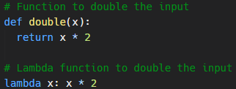
The above lambda function has the same functionality as the double function defined earlier. However, the lambda function is anonymous, as it does not have a name.
Lambda functions can have multiple arguments, just like regular functions. Here is an example of a lambda function with multiple arguments:
python
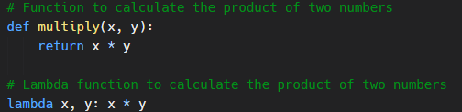
Lambda functions can also include multiple statements, but they are limited to a single expression. For example:
python
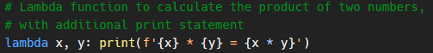
In the above example, the lambda function includes a print statement, but it is still limited to a single expression.
Lambda functions are often used in conjunction with higher-order functions, such as map, filter, and reduce which we will look into later.

